Birla Institute of Technology & Science, Pilani
Work Integrated Learning Programmes Division
Second Semester 2019-2020

Comprehensive Examination
(EC-3 Regular)

Course No. : SS ZG526
Course Title : DISTRIBUTED COMPUTING
Nature of Exam : Open Book
Weightage : 50%
No. of Pages = 3

No. of Questions = 11
Duration : 2 Hours
Date of Exam : Saturday, 11/07/2020 (AN)
Note to Students:
- Please follow all the Instructions to Candidates given on the cover page of the answer book.
- All parts of a question should be answered consecutively. Each answer should start from a fresh page.
- Assumptions made if any, should be stated clearly at the beginning of your answer.
- Use multiple diagrams to show the progress of the algorithms

- For the given set of processes P1, P2 & P3 and events “a” to “o”, in the following space-time diagram, list the vector time stamps for each of the events and using the Vector Time stamps list out all happened before relations in the given set of events. [6]
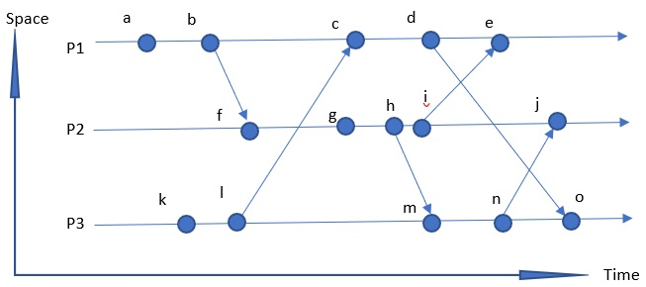

- Briefly explain the problem that the Birman- Schiper- Stephenson (BSS) protocol solves. For the given set of processes P1, P2 & P3, and events do you see any reason to apply the BSS protocol. If yes what problem you solve and how? [6]
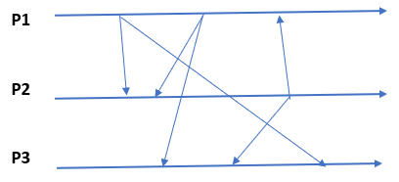

- What are the three primary requirements of mutual exclusion algorithms? Give one liner description for each. For the given sites S1, S2 & S3, and requests (a & b) to enter critical section, explain how the Ricart Agrawala will facilitate the distributed mutual exclusion. Explain the progress of the algorithm with separate space-time diagram for each step. [6]
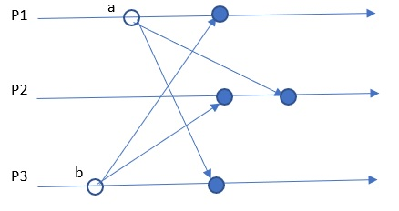

- For the given request sets R0 to R6, of sites S0 to S6, explain the working of Maekawa's algorithm, where the site S2, S6 & S4 wants to enter CS in the mentioned order. Use separate/multiple space time diagrams to show the progress of the algorithm. [6]
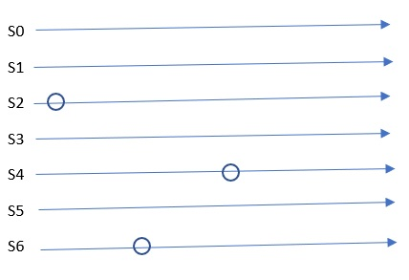
- For the given set of nodes, where P0 is the root node and holds the token, demonstrate the working of the Raymond's tree-based algorithm for DME, where the token is requested by P3 and P1 respectively. Use multiple diagrams to show the progress of the algorithm. [6]
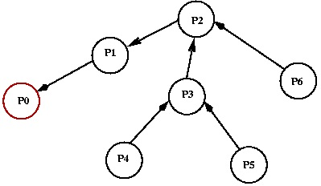

- For the given set of processes in the sites, demonstrate the working of the CHS algorithm using the AND model, where P1 initiates the deadlock detection algorithm. What is the outcome? What happens when P10 for some reason starts depending on P9? [6]
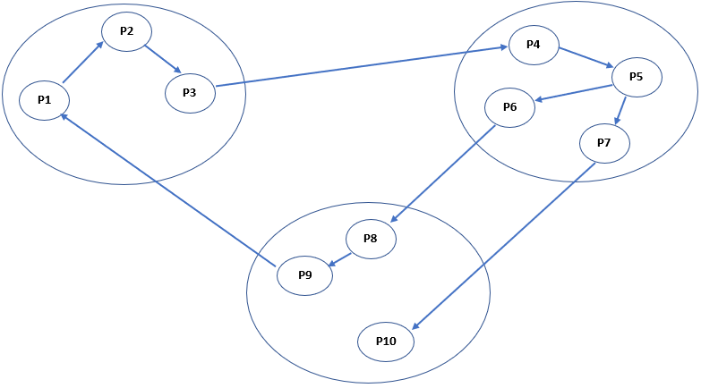
S1
S2
S3

- For the given set of 4 nodes (where n1 is the commander and rest are lieutenants) and n2 is faulty (corrupt lieutenant), what is the value of “m”? Demonstrate the working of the OM(m) through OM (0) of Byzantine agreement. Use only 0 (for R retreat) and 1 (for A attack) as message. [6]
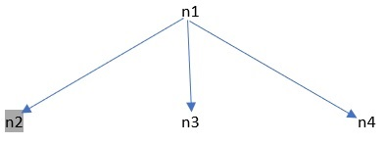

- Explain with an illustration of your choice, what is the difference between a Cycle & Knot.
[2]

- Briefly describe what are Application layer overlays. [2]

- What are the components of a RFID system? Give one liner description of each. [2]

- List and briefly elaborate the design principles of computer clusters. [2]

***********

